Javascript Interview and code questions basic to advanced
Qu.1 Var,let, const difference
var | let | const
Function scoped | Block scoped | Block scoped
Can be redeclared | Cannot be redeclared | Cannot be redeclared
Can be reassigned | Can be reassigned | Cannot be reassigned
Hoisted with undefined | Hoisted (TDZ) | Hoisted (TDZ)
Use const whenever possible.
Use let if the value changes.
Avoid var in modern applications.
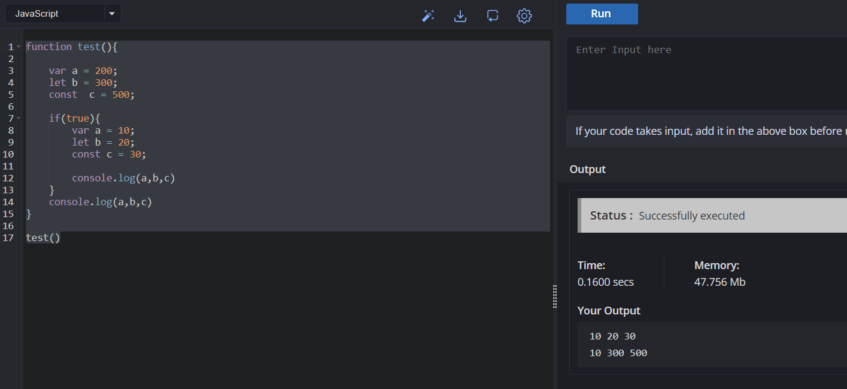
//function scope is created for var, so new scope is not created, hence value remains 100
2. What is Temporal Dead Zone (TDZ)?
Answer
The Temporal Dead Zone (TDZ) is the period between entering a block scope and the point where a variable declared with let or const is initialized.
During this period, the variable exists but cannot be accessed. Attempting to do so throws a ReferenceError.
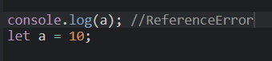
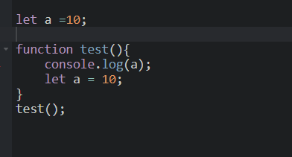
3. Can const objects be modified?
"const does not make an object immutable. It only makes the reference immutable. We can modify the object's properties or array elements, but we cannot reassign the variable to point to a different object or array. If true immutability is required, we can use Object.freeze()."
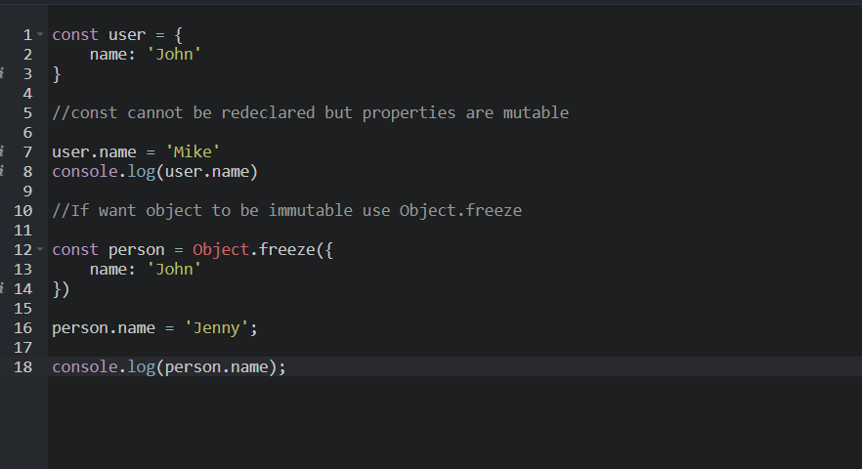
2. What is a Shallow Copy?
Answer
A shallow copy creates a new outer object, but nested objects or arrays are still shared by reference.
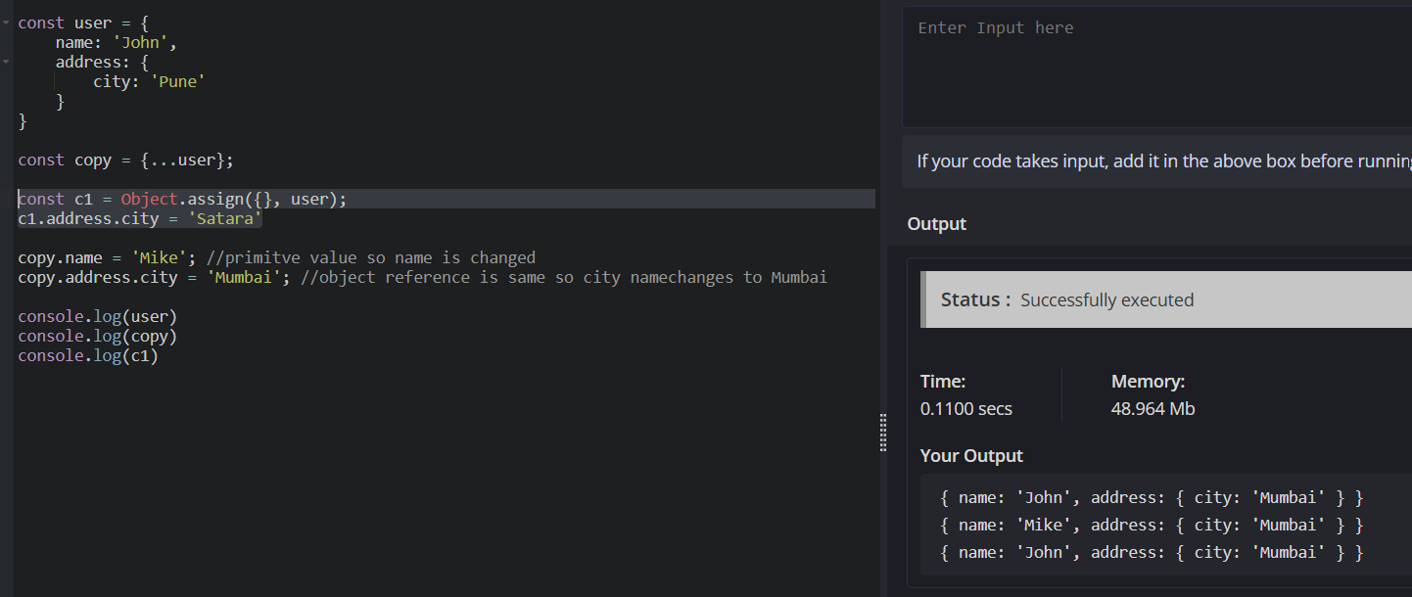
Deep Copy
A deep copy duplicates every nested object and array, so changes in the copy do not affect the original.
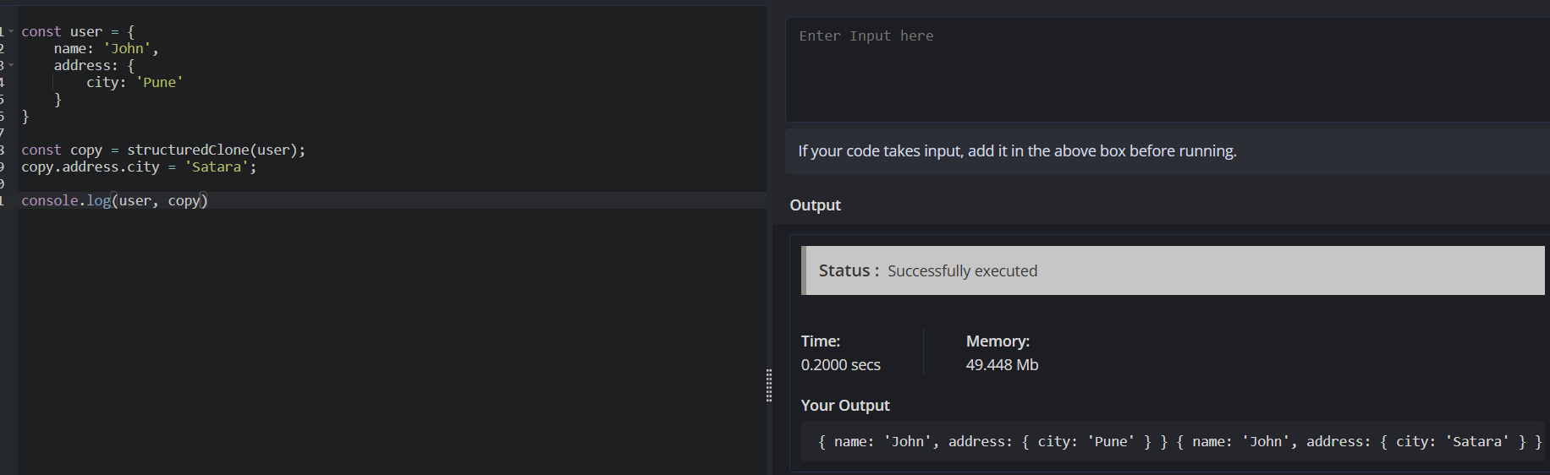
Qu. Can Arrow Functions be replaced with function expressions regularly
Function declarations are fully hoisted, whereas function expressions are available only after their assignment executes. In Angular, class methods and arrow functions are used most frequently, especially for RxJS callbacks and event handlers. Arrow functions can replace most function expressions, but not all regular functions because they don't have their own this, cannot be used as constructors with new, and don't provide their own arguments object.
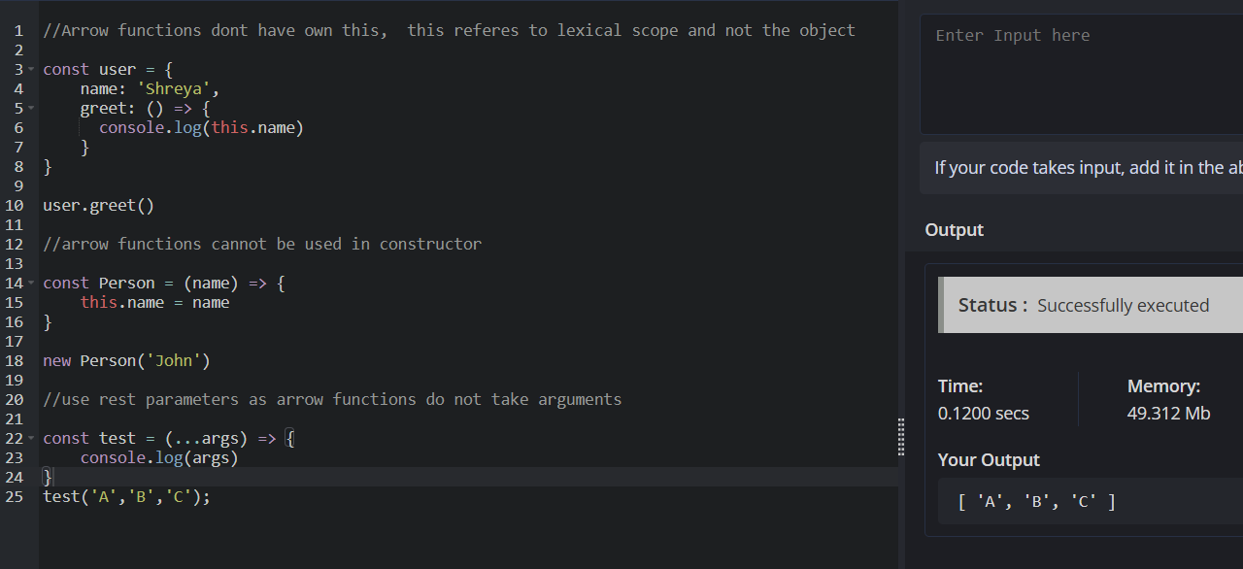
Rest collects multiple arguments into an array.
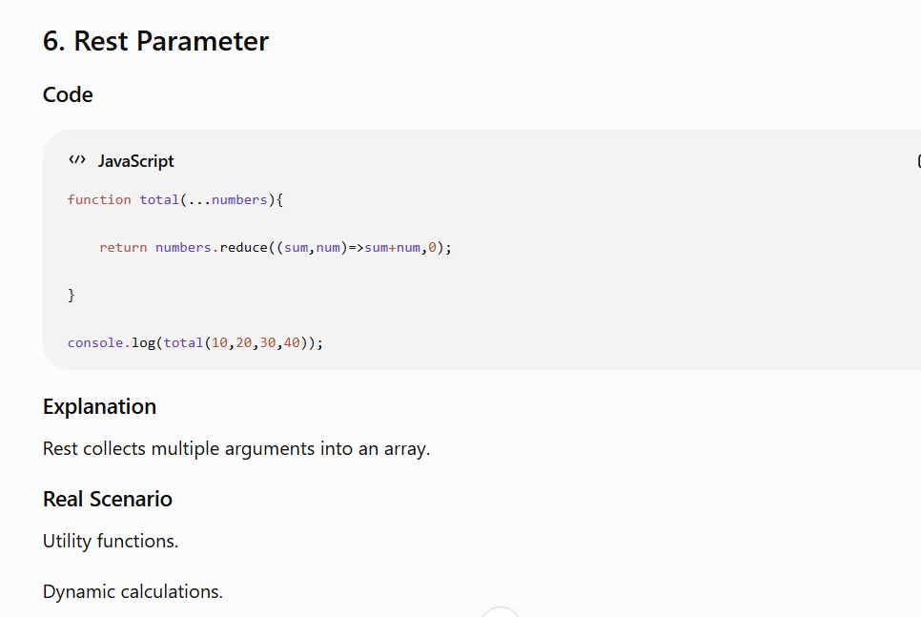
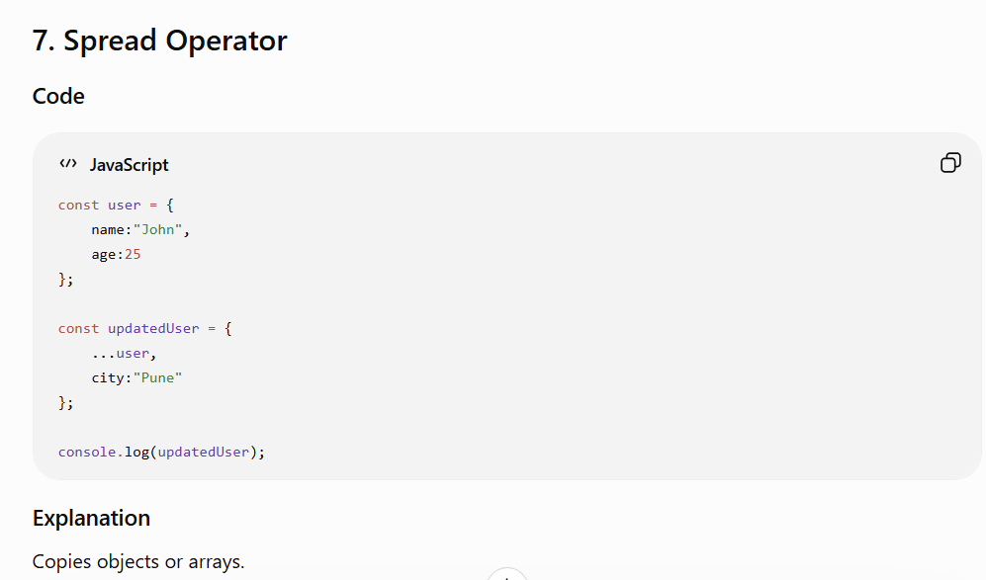
Qu. Remove Duplicate Values from an Array
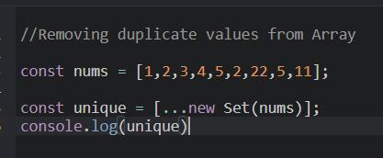
Qu. What happens when the function is assigned to another variable?
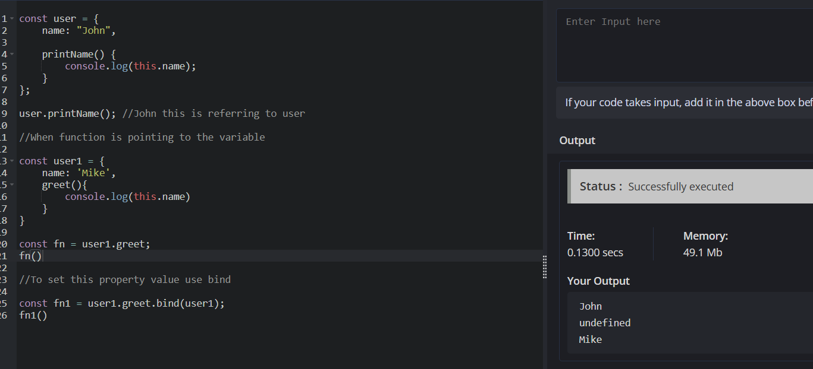
When a function is assigned to another variable, is a plain function call, with no owning object, so this is no longer user.greet can be accessed .

Qu. What is call ?
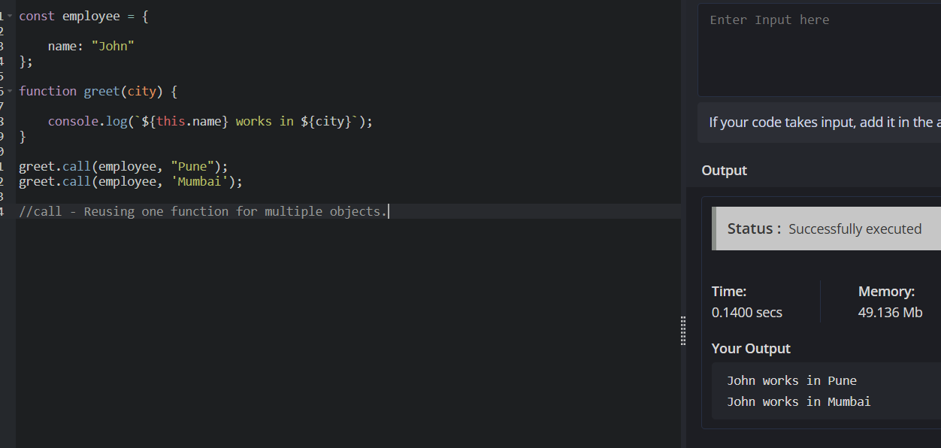

bind() permanently sets the value of this.
Qu. How to create own promise?
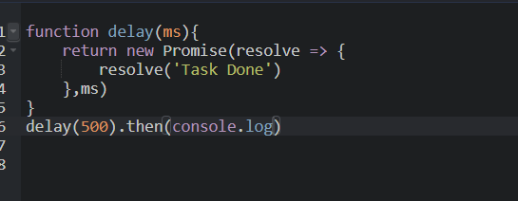
Promise chaining

function fetchUser() {
return new Promise((resolve, reject) => {
setTimeout(() => {
console.log('Fetching User Data...')
resolve({
userId: '101',
userName: 'Shreya'
})
}, 500);
})
}

function fetchOrder(userId, userName) {
return new Promise((resolve, reject) => {
setTimeout(() => {
console.log(`Fetching Order Details.. for ${userId} Name : ${userName}`)
resolve([
{
orderId: '5001',
orderDetails: 'Laptop'
},
{
orderId: '5002',
orderDetails: 'Mouse'
}])
}, 500);
})
}

function fetchinvoice(orders) {
return new Promise((resolve, reject) => {
setTimeout(() => {
console.log('Order Details..');
resolve({
invoiceId: '2001',
totalOrders: orders.length
})
}, 500)
})
}

fetchUser()
.then(res => {
console.log('User: ', res)
return fetchOrder(res.userId, res.userName)
})
.then(res => {
console.log('Orders ', res)
return fetchinvoice(res)
})
.then(res => {
console.log(res)
})
.catch(err => {
console.log(err)
})

